Week 3 Lab

Module 1: Exploring Agile Values

Coursera.org – Agile Project Management

Robert Brenckman
Charter Oak State College
ITE 215: Software Develop Method & Languages
COSC_ITE215012526FACR
John Rusnak
11/15/2025

Why teams adopt the agile approach
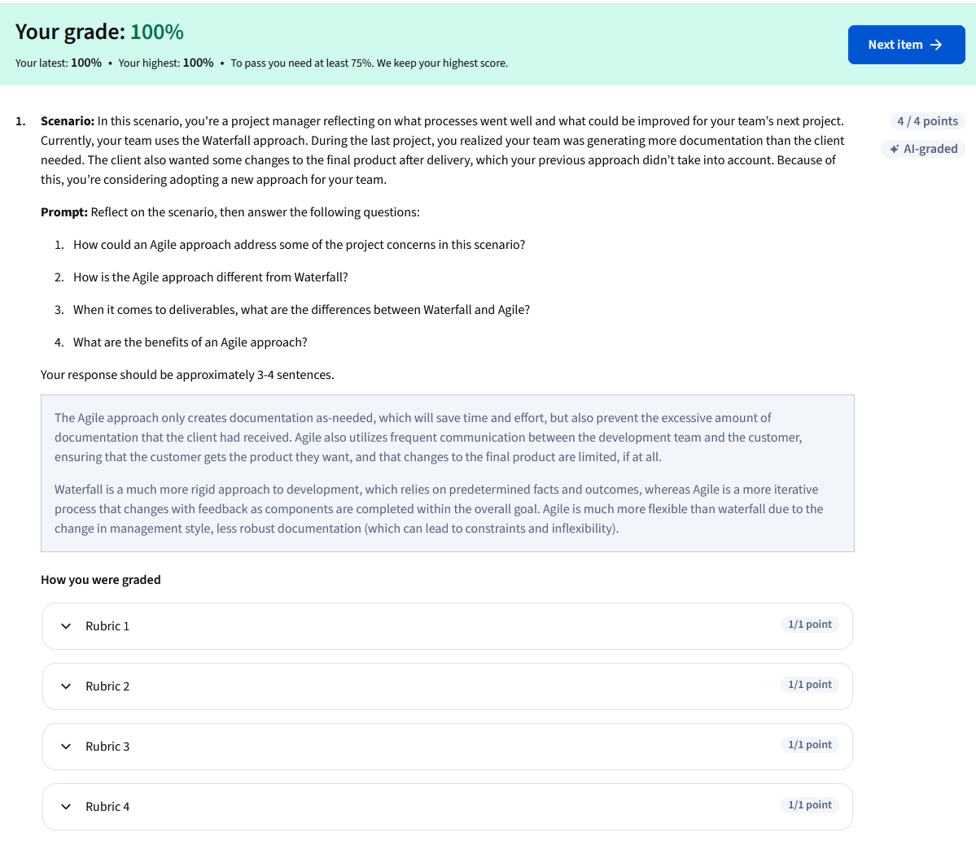

Explore : Agile Values
